Mathematics Project

Topic: Height & Distance

Height & Distance: Application in Trigonometry

* How Heights & Distances are extensively used in real-life

**Introduction**: Let’s see a practical example where we would try to find out the need of “Height and Distance” theory in mathematics.

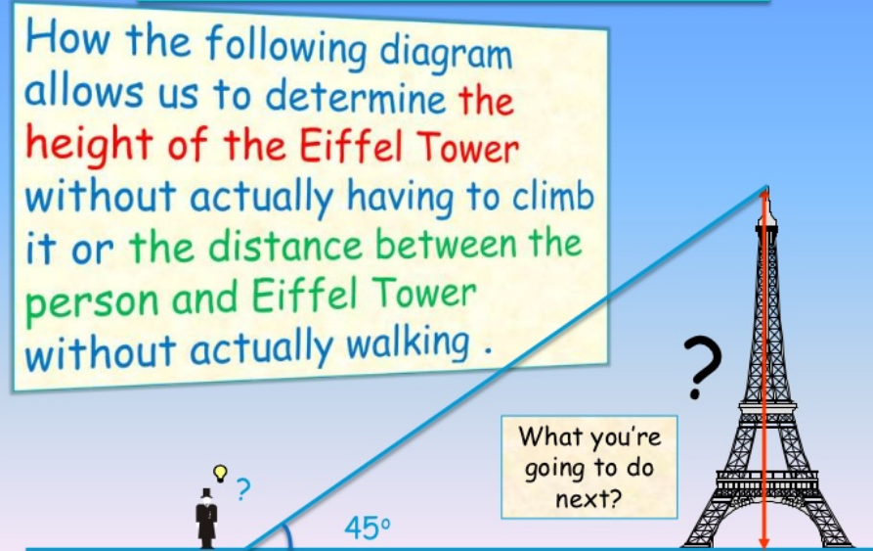

In the above situation, the distance or the heights can be founded by using mathematical techniques, which comes under a branch of ‘trigonometry’. The word ‘trigonometry’ is derived from the **Greek** word ‘**tri’** meaning three, ‘**gon’** meaning sides and ‘**metron’** meaning measures.

So three-sides-measures concept i.e. relationship between angles and sides of triangles can be applied in the above application to find the heights/distances of **objects.**

**Techniques followed:** Here are the three different techniques can be used to measure the height of the tower or the distance between the person and the tower

Technique1:

If the tower is sitting in the middle of a flat field, probably the easiest technique is to use its shadow on a sunny day. Take a broomstick, a hammer and a measuring tape with you. Pound the broomstick into the ground a few inches so it stands up on its own. If you are patient, you can wait until the length of the broomstick's shadow is equal to the length of the visible broomstick and then go measure the length of the tower's shadow. The length of the shadow tells you the height of the tower directly.

Technique2:

you need a drinking straw, a protractor, some scotch tape and a measuring tape. Tape the drinking straw to the protractor at the 45-degree angle mark. Hold the protractor with its flat side level with the horizon and then sight through the drinking straw. Walk a distance away from the tower until you can see the top of the tower through the straw. Since you are sighting the top of the tower at a 45-degree angle, your distance from the tower is equal to the height of the tower. Measure your distance from the tower and you know its height.

Technnique3:

you need a protractor, drinking straw, tape measure and a calculator that will handle trigonometric functions. Stand somewhere where you can easily measure your distance to the tower. Sight through the drinking straw and find the top of the tower, and then measure the angle between the straw and the horizon using the protractor. Let's say the angle is 55 degrees, and the distance to the base is 200 feet. The equation to use is:

Height of tower = distance from tower * tan(angle)

So,

Height of tower = 200 feet * tan(55 degrees) = 200 feet * 1.43 = 286 feet

Following are some real-life applications of Height and Distance in Trigonometry:

* In Aviation or Flight Engineering:

As we know that when a flight or an aeroplane is flying in the sky then it is more affected by the wind. Thus, wind plays an important role in aviation technology.

The wind of flight direction is considered as the two perpendicular sides of a right-angled triangle in which the speed of wind and speed of the flight is measured in their direction.

Thus, by using the definition of trigonometrical ratios, we can easily calculate the direction of the destination and also the height of the flight from the ground. Therefore, flight engineering is the real life application of trigonometry and height & distance.

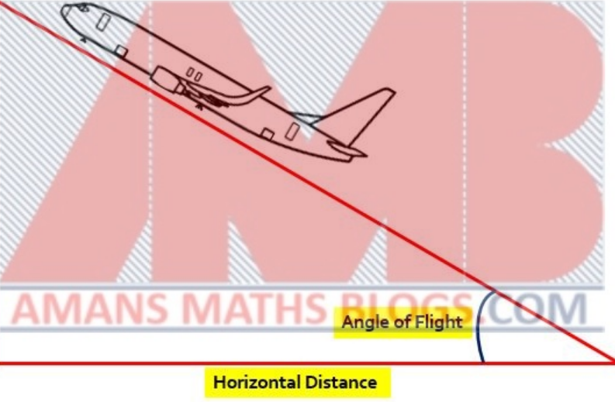

For example, if a plane is travelling at 234 mph, 45 degrees N of E, and there is a wind blowing due south at 20 mph. Trigonometry will help to solve for that third side of your triangle which will lead the plane in the right direction, the plane will actually travel with the force of wind added on to its course.

* Key features:

Landing: When pilots are landing, they need to visually maneuver their plane to find an approach angle. They have to take into account obstructions, noise abatement, other planes, and weather conditions. The standard angle though is 3 degrees. The final approach is usually achieved at 500 feet.

With this, you may find your distance (X) from your destination using the tangent of 3 degrees (in this example) equals the height (500 ft) over X.

Take-off Speed: If you want to take-off successfully, you need to know what angle the wind is coming at you on the runway.

You know what angle the wind is coming at you. You also know how fast it is coming at you. So, you’d use cosine to figure out how fast you need to take off.

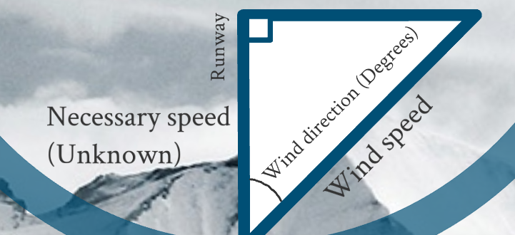

Conclusions:

* The concept of ‘Height & Distance’ in trigonometry can be used in many areas such as astronomy and architecture they can aid in calculating many things they can also be used in cars desks and benches. Without really climbing a tree, you can find the height easily with this concept. They can be so widely used in real life applications and is very useful for most architects and astronomers.
* We can conclude that without trigonometry, life would be much more difficult. Without going through the troubles, you can easily find something so we think that it was a good invention by Archimedes and thanks to this many architects need not go through the trouble to calculate things, so it really helps in real life applications and not only in our tests and exams.